SCHOOL OF COMPUTER SCIENCE AND ARTIFICIAL INTELLIGENCE |  |  |  |  | DEPARTMENT OF COMPUTER SCIENCE ENGINEERING
Program Name: B. Tech |  |  |  | Assignment Type: Lab |  |  | Academic Year:2025-2026
Course Coordinator Name |  |  |  | Venkataramana Veeramsetty
Instructor(s) Name |  |  |  | Dr. V. Venkataramana (Co-ordinator)  Dr. T. Sampath Kumar  Dr. Pramoda Patro  Dr. Brij Kishor Tiwari  Dr.J.Ravichander  Dr. Mohammand Ali Shaik  Dr. Anirodh Kumar  Mr. S.Naresh Kumar  Dr. RAJESH VELPULA  Mr. Kundhan Kumar  Ms. Ch.Rajitha  Mr. M Prakash  Mr. B.Raju  Intern 1 (Dharma teja)  Intern 2 (Sai Prasad)  Intern 3 (Sowmya)  NS2 ( Mounika)
Course Code |  |  | 24CS002PC215 | Course Title |  | AI Assisted Coding
Year/Sem |  |  | II/I | Regulation |  | R24
Date and Day  of Assignment |  |  | Week2 - Monday | Time(s)
Duration |  |  | 2 Hours | Applicable to  Batches
Assignment Number:3.1(Present assignment number)/24(Total number of assignments)
 | Q.No. | Question |  |  |  |  |  | Expected Time to complete
 | 1 | Lab Experiment: Prompt Engineering – Improving Prompts and Context Management (0.5 marks)  Objective  To explore how prompt design and context influence AI-generated outputs and to learn techniques to improve AI responses.  Tools Required  - GitHub Copilot / Google Gemini / ChatGPT  - VS Code / Google Colab  - Internet access  Procedure  - Select a simple task: "Write a Python function to check if a number is prime."  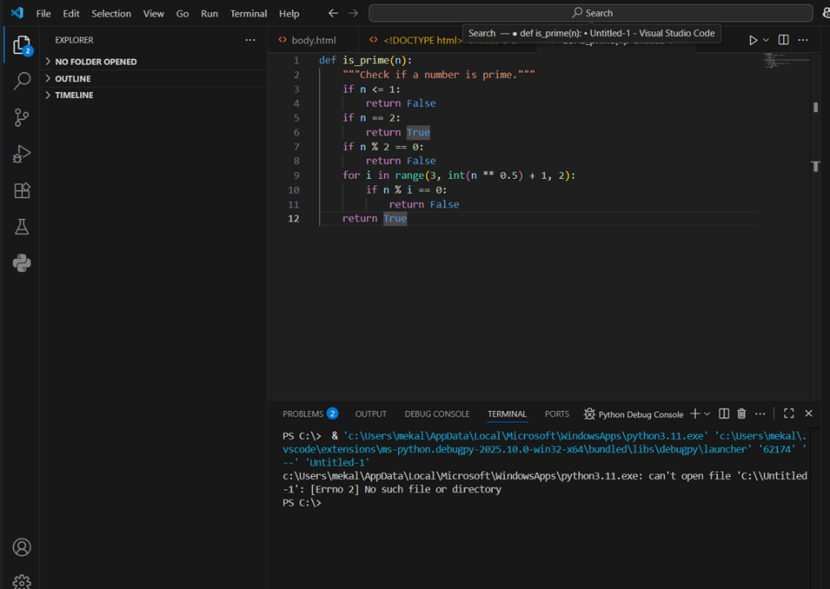  - Use different prompting strategies to generate the solution:  - Zero-Shot – no examples.  - One-Shot – one example provided.  - Few-Shot – multiple examples provided.  - Context-Managed – detailed prompt with constraints and instructions.  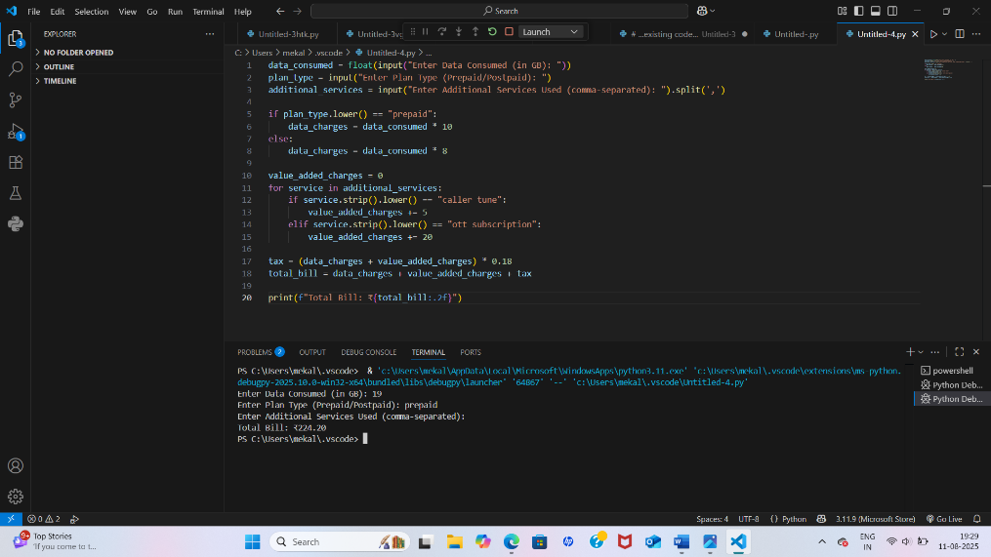  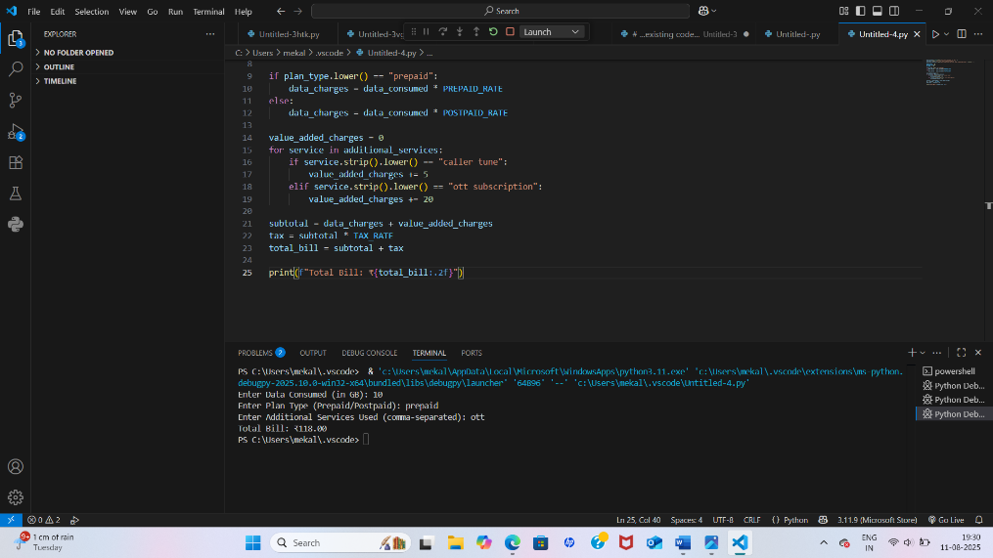  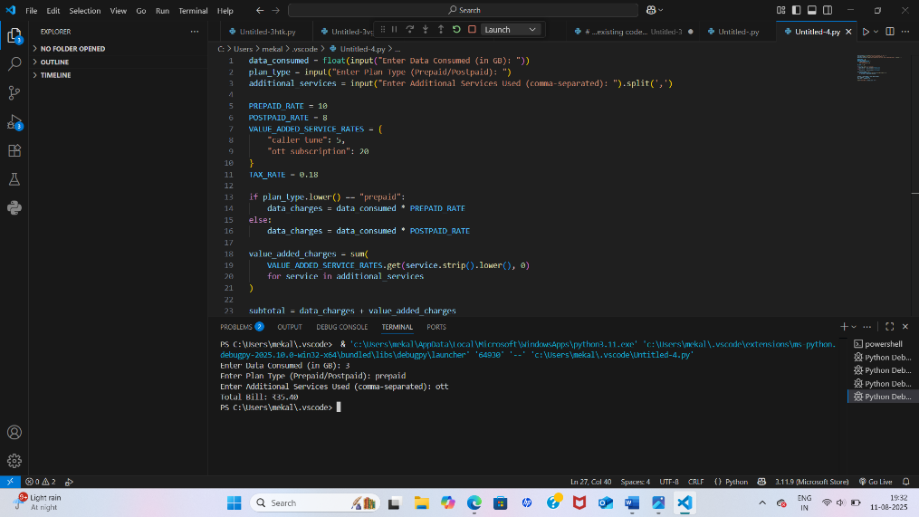  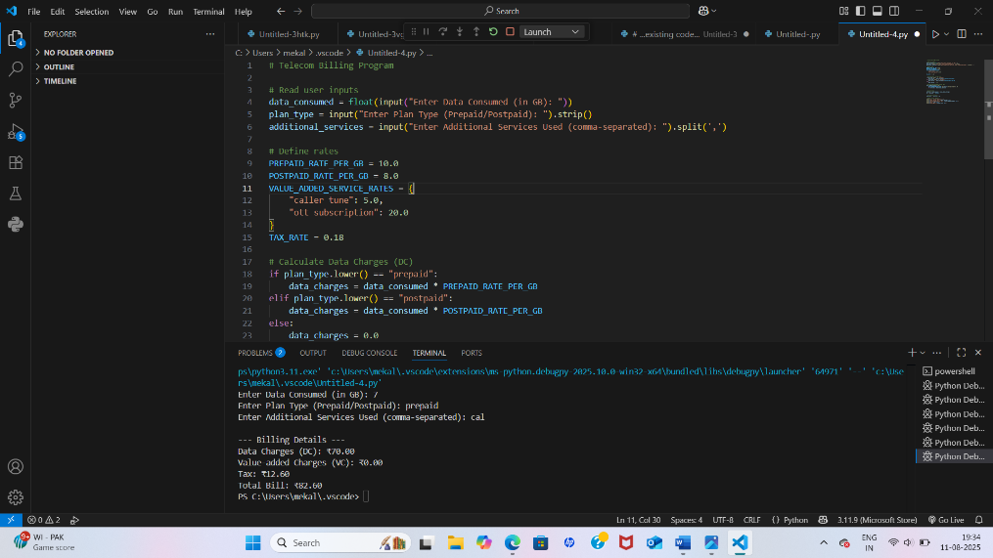  - Record AI responses and refine prompts to improve code quality.  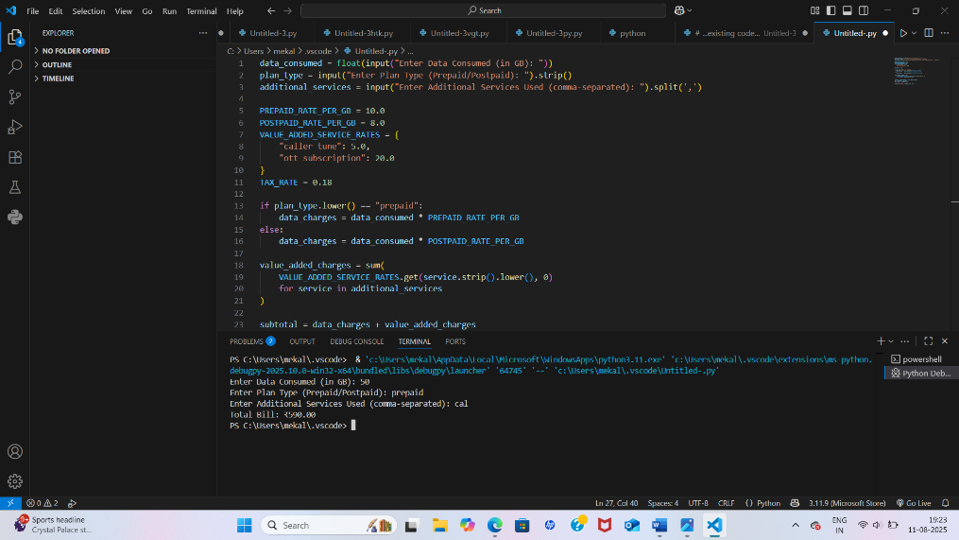  - Request AI to optimize the logic for efficiency.  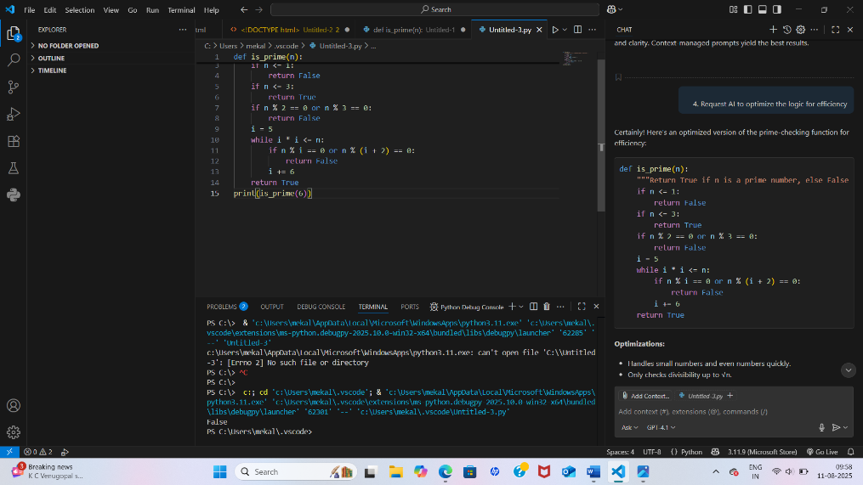  - Compare results and document improvements.  - Sample Prompts  - Zero-Shot:  Write a Python function to check if a number is prime.  - One-Shot:  Example: Input: 5 → Output: Prime. Now, write a function to check if a number is prime.  - Few-Shot:  Example 1: Input: 7 → Output: Prime  Example 2: Input: 10 → Output: Not Prime  Example 3: Input: 2 → Output: Prime  Generate the function accordingly.  - Context-Managed (With Optimization) |  |  |  |  |  | Week2 - Monday
 | 2 | Task: Mobile Data Usage Billing Application (1.0 Marks)  Objective:  Use Python programming and AI-assisted coding tools to create an application that simulates mobile data billing for a telecom service provider.  Instructions  - Use GitHub Copilot or Google Gemini to assist in writing the program.  - Read the following inputs from the user:  - Data Consumed (in GB)  - Plan Type (Prepaid / Postpaid)  - Additional Services Used (e.g., caller tune, OTT subscription, etc.  - Implement billing logic to calculate:  - DC (Data Charges) – charges based on data consumption  - VC (Value-added Charges) – charges for additional services  - Tax – applicable tax on the total bill  - Display an itemized bill showing:  - Plan Type  - Data Usage and Charges  - Value-added Services and Charges  - Tax  - Total Bill Amount  Requirements  - Students must refer to their actual mobile bill for charge structure (data cost, service fees, taxes) to make the program realistic.  - AI assistance (Copilot/Gemini) must be used to generate and refine the initial code.  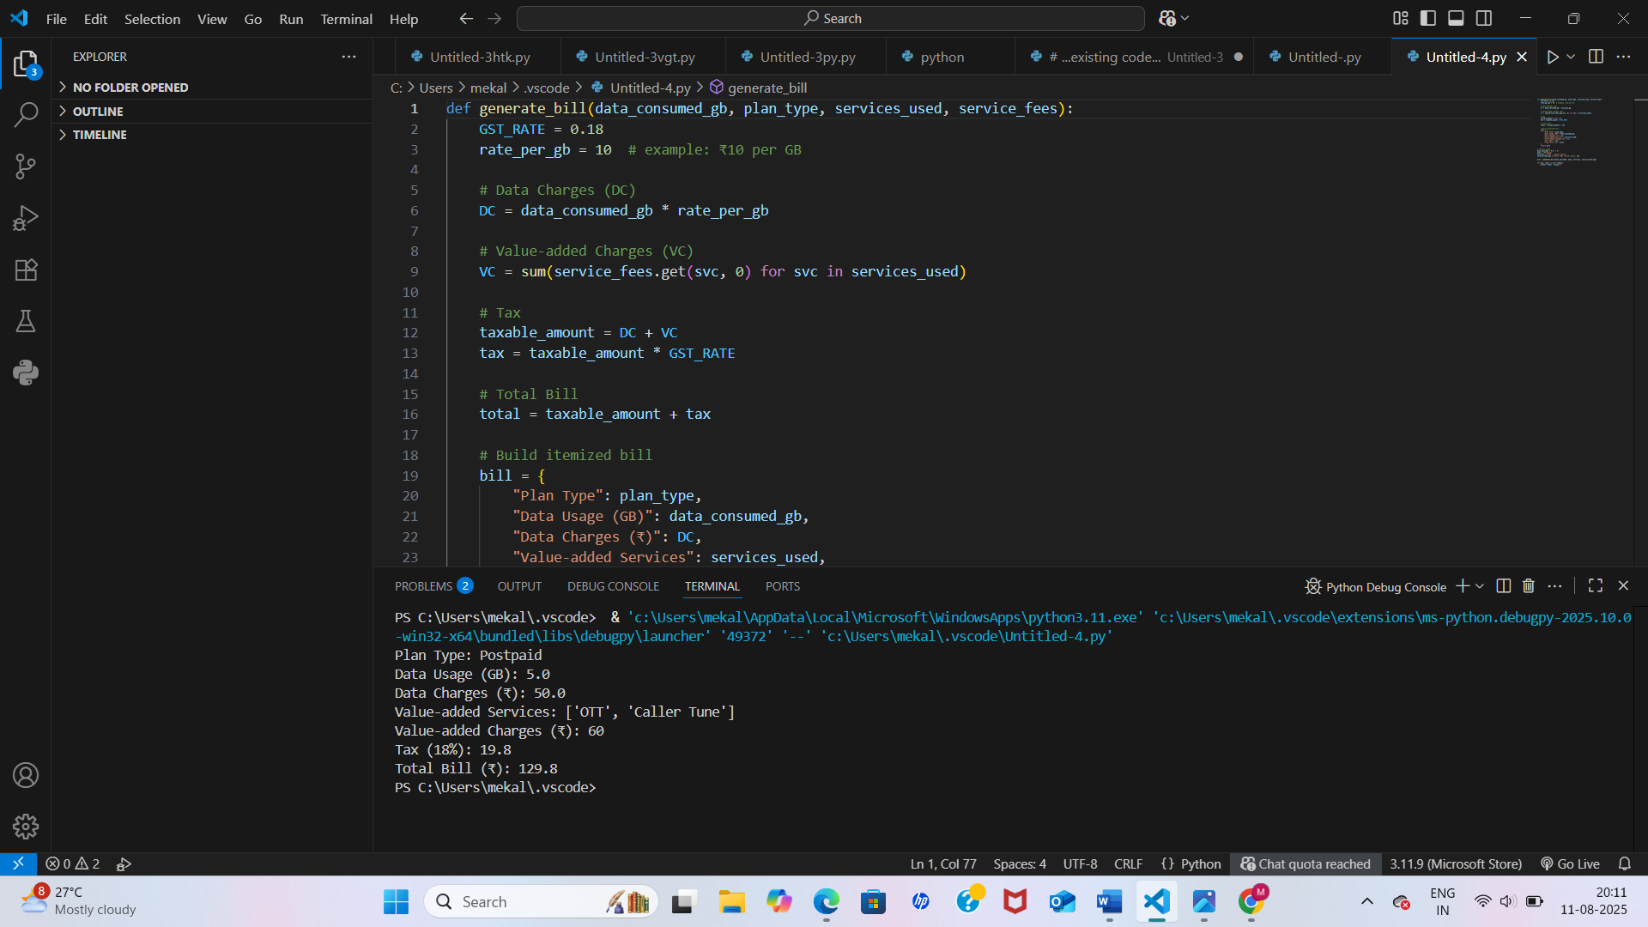  Deliverables  - AI prompts used for code generation.  - AI-generated Python code and any optimized version.  - Screenshots of:  - AI interactions  - Program execution and output  - Comparison with the student’s actual mobile bill. |  |  |  |  |  | Week2 - Monday
 | 3 | Task: Develop an LPG Billing System (1.0 Marks)  Objective  Apply your Python programming skills and utilize AI-assisted coding tools to build an application that calculates the LPG bill based on specified customer inputs and billing parameters.  Instructions  - Use GitHub Copilot or Google Gemini to assist in writing and refining the program.  - Read the following user inputs:  - Cylinder Type (Domestic 14.2 kg / Domestic 5 kg / Commercial 19 kg / Commercial 47.5 kg)  - Number of Cylinders Booked  - Subsidy Amount (applicable only for domestic cylinders)  - Refer to the given LPG Price List to determine the price per cylinder:  - Domestic LPG (14.2 kg) → ₹905.00  - Domestic LPG (5 kg) → ₹335.50  - Commercial LPG (19 kg) → ₹1,886.50  - Commercial LPG (47.5 kg) → ₹4,712.00  - Delivery Charges (₹10 to ₹50)  - Implement the billing formula:  Bill Amount = (Price per Cylinder × Quantity) - Subsidy (if applicable) + Delivery Charges  - Calculate and display an itemized bill including:  - Cylinder Type  - Number of Cylinders  - Base Amount  - Subsidy  - Delivery Charges  - Total Bill Amount  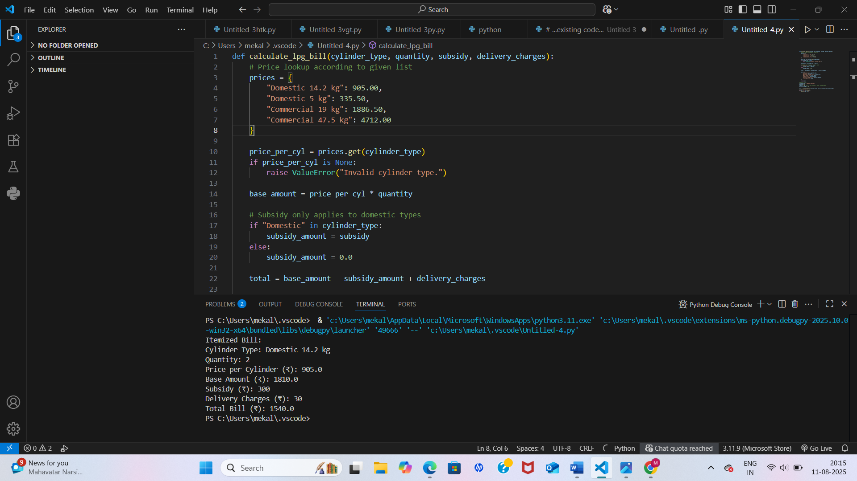  Deliverables  - A report containing:  - AI prompts used to generate the program  - AI-generated Python code  - Line-by-line explanation of the code |  |  |  |  |  | Week2 - Monday

